4.6 Exercises

4.6.1 Variability in estimates

4.1 Identify the parameter,

Part I. For each of the following situations, state whether the parameter of interest is a mean or a proportion. It may be helpful to examine whether individual responses are numerical or categorical.

Mean – numerical, Proportion-Categorical

(a) In a survey, one hundred college students are asked how many hours per week they spend on the Internet. Mean

(b) In a survey, one hundred college students are asked: “What percentage of the time you spend on the Internet is part of your course work?” Mean

(c) In a survey, one hundred college students are asked whether or not they cited information from Wikipedia in their papers. Proportion

(d) In a survey, one hundred college students are asked what percentage of their total weekly spending is on alcoholic beverages. Mean

(e) In a sample of one hundred recent college graduates, it is found that 85 percent expect to get a job within one year of their graduation date. Proportion

4.2 Identify the parameter,

Part II. For each of the following situations, state whether the parameter of interest is a mean or a proportion.

(a) A poll shows that 64% of Americans personally worry a great deal about federal spending and the budget deficit. Mean

(b) A survey reports that local TV news has shown a 17% increase in revenue between 2009 and 2011 while newspaper revenues decreased by 6.4% during this time period. Mean

(c) In a survey, high school and college students are asked whether or not they use geolocation services on their smart phones. Proportion

(d) In a survey, smart phone users are asked whether or not they use a web-based taxi service. Proportion

(e) In a survey, smart phone users are asked how many times they used a web-based taxi service over the last year. Mean

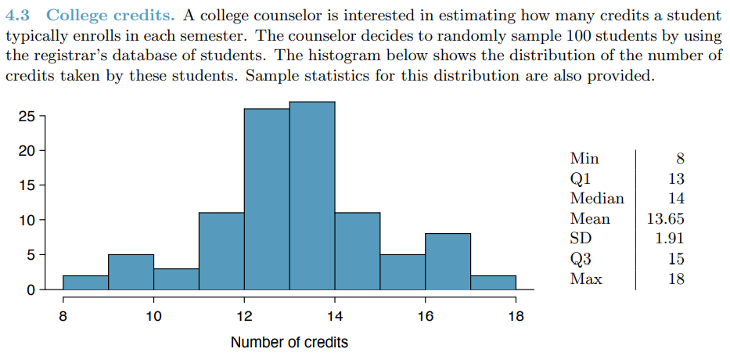

(a) What is the point estimate for the average number of credits taken per semester by students at this college? What about the median? Avg No of credits=13.65, Median=14

(b) What is the point estimate for the standard deviation of the number of credits taken per semester by students at this college? What about the IQR? SD=1.91; IQR=15-13=2;

(c) Is a load of 16 credits unusually high for this college? What about 18 credits? Explain your reasoning. Hint: Observations farther than two standard deviations from the mean are usually considered to be unusual. Z16 = 1.23, which is not unusual since it is within 2 SD of the mean. Z18 = 2.28, which is generally considered unusual.

(d) The college counselor takes another random sample of 100 students and this time finds a sample mean of 14.02 units. Should she be surprised that this sample statistic is slightly different than the one from the original sample? Explain your reasoning. No. Point estimates that are based on samples only approximate the population parameter, and they vary from one sample to another.

(e) The sample means given above are point estimates for the mean number of credits taken by all students at that college. What measures do we use to quantify the variability of this estimate (Hint: recall that SDx¯ = p/n )? Compute this quantity using the data from the original sample. We use the SE, which is 1.91/ √100 = 0.191 for this sample’s mean.

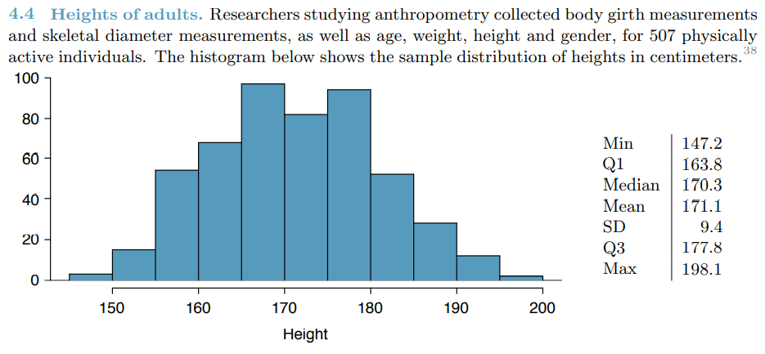

1. What is the point estimate for the average height of active individuals? What about the median?

Point Estimate🡪Mean🡪171.1; Median🡪170.3

(b) What is the point estimate for the standard deviation of the heights of active individuals? What about the IQR? SD🡪9.4; IQR🡪177.8-163.8=14;

(c) Is a person who is 1m 80cm (180 cm) tall considered unusually tall? And is a person who is 1m 55cm (155cm) considered unusually short? Explain your reasoning.

(d) The researchers take another random sample of physically active individuals. Would you expect the mean and the standard deviation of this new sample to be the ones given above? Explain your reasoning. No. Point estimates that are based on samples only approximate the population parameter, and they vary from one sample to another

(e) The sample means obtained are point estimates for the mean height of all active individuals, if the sample of individuals is equivalent to a simple random sample. What measure do we use to quantify the variability of such an estimate (Hint: recall that SDx¯ = p/√n )? Compute this quantity using the data from the original sample under the condition that the data are a simple random sample. We use the SE, which is 9.4/ √500 = 0.42 for this sample’s mean.